I have chosen a sample of some of the questions from the government website: http://www.ed.gov.nl.ca/edu/k12/evaluation/history3201.html#resources

There are others there under Grading Standards located on the bottom of the page. This is an invaluable study aid for you to use throughout this course. Please use it in preparation for unit tests. You will be very happy you did☺.

Rubric for 5 Mark Questions on the Public
This is a standard template used to grade your answers on the public. I will be using the same for all assessment in this course
Remember 2 marks for your comments on the source and marks 3 for your own knowledge of the subject.
5 point questions:
Use of Document: 2%
2 % Superior 2 references with little extension or 1 reference with
considerable extension
1 % Limited 1 reference with little extension
0% Inappropriate or no reference to the document

Use of Own Knowledge: 3%
3% Superior 3 references with little extension or 2 with adequate extension
or 1 reference with considerable extension
2% Adequate 2 references with little extension or 1 with adequate extension
1% Limited 1 reference with little extension
0% Inappropriate or no reference to own knowledge

Sample questions:
Based on the source below and your knowledge of history, explain the origins of the First
World War.

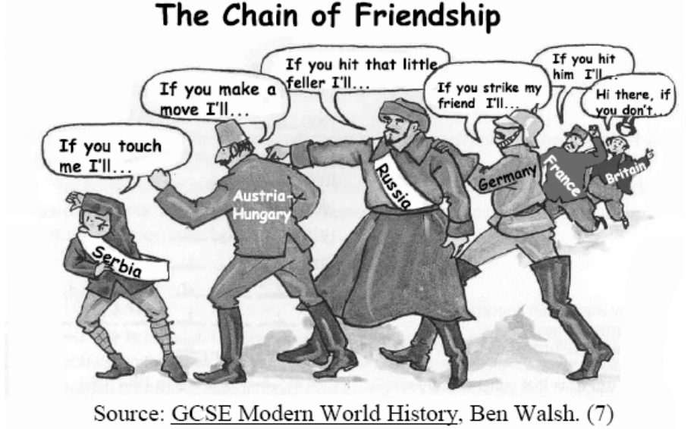
Use of Source
This source had several elements that students could use:
• The title is “Chain of Friendship”.
• Serbia is smaller, in the front, and trying to protect itself.
• The next three larger figures/countries are Austria-Hungary, Russia and Germany. They
seem to be stepping in front of the other.
• France and Britain are in the background.
• They each claim “if you hit….”, the other will step in.
Points from the source that a student could reference include:
• System of alliances/chain of friendship was a key factor in outbreak of the First World
War.
• Russia is threatening to protect Serbia from Austria-Hungary.
• Germany is telling Russia that if Russia strikes Austria-Hungary, Germany will do
something in response.
• France and Britain are doing the same.
Use of Knowledge
• The origins of the First World War refer to nationalism, economic rivalry (imperialism),
the arms race and military alliances.
• By 1907 Europe was split into two armed camps. This started under Bismarck of
Germany, who had earlier feared the French desire for revenge after the loss of Alsace-
Lorraine. He wanted to isolate France.
• The main alliances were Britain, France and Russia (the Triple Entente) and Germany,
Austria-Hungary and Italy (the Triple Alliance).
• Alliance systems meant that a dispute between one member of each camp could easily
involve the others, thus a war between two countries involves all six.
• Serbia provided the “spark”; Archduke Ferdinand`s assassination by Gavrilo Princip, a
Bosnian Serb.
Based on the source below and your knowledge of history, explain the impact the Treaty of
Versailles had upon German stability during the post-war period.

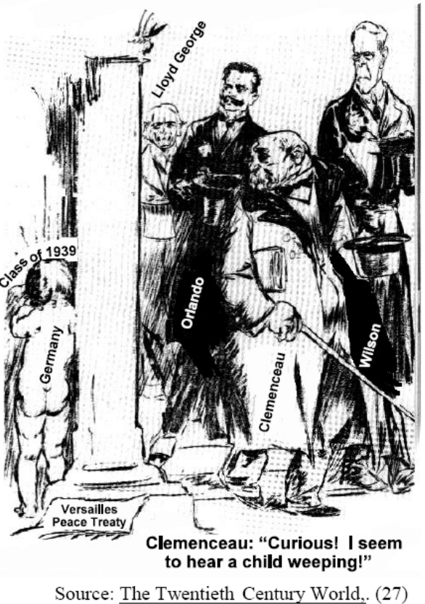
Use of Source
The visual shows:
• The Treaty of Versailles on the floor or ground.
• To the left of the wall or pillar, Germany is portrayed as a small child – alone, naked, and
from the back view, labeled the “Class of 1939”.
• To the right, the members of the Big 3 (or Big 4) are standing. Clemenceau is in front,
saying it’s curious that he hears a child weeping.
Points from the source that a student could reference include:
• Germany, the child, is weeping because of its treatment due to the clauses of the Treaty
of Versailles authored by the victorious allies pictured. The year 1939 marks the
beginning of The Second World War, with Hitler leading Germany.
• The Big Three leaders (Orlando of Italy = Big Four)
• Clauses in the treaty that Germans felt were harsh.
Use of Knowledge
Economic Stability:
• Economically, the reparations Germany had to pay were excessive. Extra money was
printed, which led to hyper-inflation, and subsequently, economic collapse.
• Germany lost ten percent of its land, all overseas colonies, 12.5% of its population, 16%
of its coalfields in the Saar Valley and its iron also.
• Germany’s inability to pay reparations led to an occupation of industrial Germany (the
Ruhr) by France and Belgium from 1922 to 1923. This led Germans to further resent the
Allies and the inability of their own Weimar government to stop the Allied occupation.
• Germany’s economic situation was relieved in 1924 by the American sponsored Dawe’s
Plan which adjusted reparations payments and provided Germany with loans to help
stabilize their economy. This plan was very successful and from 1924-1929 the economic
situation in Germany was much better
• With this economic stability came political stability until 1929 when the Dawe’s Plan
eventually failed as it was entirely dependent on the strength of the American economy.
This made Germany the hardest-hit European country during the early stages of the Great
Depression.
Political Stability:
• Overall, the unfavorable economic and political terms as dictated by the Big 3 (or Big 4)
infuriated and humiliated many Germans. Hitler later used it to seek revenge as it
provided fertile ground for propaganda against the Allies.
• Germany’s army was reduced to 100,000 men; it had no air force and a very small navy.
• The hated ‘War Guilt Clause’ was even more humiliating. Many turned to right-wing
political groups, hence the rise of the Nazis.
• Too many political parties in the Reichstag meant that any government in Germany was
unstable. This often left Weimar governments at the mercy of extremist parties like the
National Socialist Party (Nazis).
• The Treaty did not bring resolution, but rather encouraged revenge.
• Germany was initially not allowed to join the League of Nations.
• German violations of the treaty grew bolder until Hitler and the Nazis killed the Treaty in
1933.

Based on the source below and your knowledge of history, explain the
reasons for the expansion of imperial powers at the turn of the 20th century.

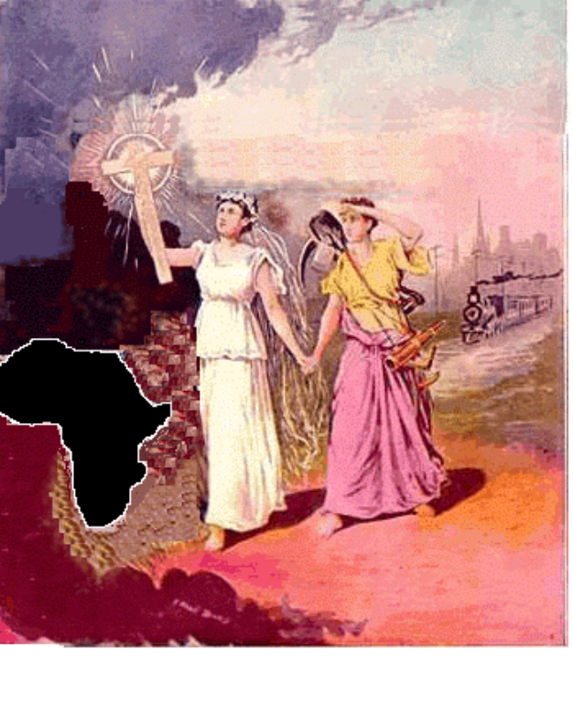
The Source is called The Light of the World and two angels named Christianity and Civilization Descend upon Africa.
Use of Source
• The source depicts the role of nations to enlighten the uncivilized people in the
colonies through the “Word of God” or the “Light of the World.”
• Symbols from the source that students might reference include:
i) The cross
ii) The images of “Christianity” and “Civilization” walking towards
Africa
iii) The train (at the time the symbol of modern day civilization) in the
background
iv) The city

Use of Knowledge
• Nationalism, or the feeling of superiority, as expressed by controlling colonies,
was a driving force of the era. Trying to keep up with other nations and
possessing colonies portrayed the image of a strong nation.
• Economic reasons included the quest for resources and markets for the benefit of
imperial nations.
• Ideological/political reasons include racial motivations of the time. (ie. the ideas
of “White Man’s Burden,” “Scramble for Africa” and “ Manifest Destiny”)
• God, Glory and Gold

Based on the source below and your knowledge of history, assess the issue of
responsibility for the outbreak of the First World War.

Source
“He [Kaiser Wilhelm II] has ruined his country, I look upon him as the greatest
criminal known for having plunged the world into this ghastly war which has
lasted for over 4 years and 3 months with all its misery.”
- King George V of Great Britain, Nov. 1918
Source: Paris 1919, Margaret MacMillan, (163)

Use of Source
• Many people blamed Germany for starting the war. As King George V states in
the document, “Kaiser Wilhelm II the leader of Germany … greatest criminal
known, plunged the world into a ghastly war.”
• The students should have identified that the issue of responsibility was
controversial and should have argued in support of German responsibility or in
support of collective responsibility.

Use of Knowledge
• Causes of WWI (nationalism, alliances, militarism and economic rivalry)
• Causes were shared by all major nations prior to WWI, so all nations can be
blamed for the war
• Attitude of nations that it would be a short war
• Pax Britannia
• Status quo of British supremacy
• Technological developments (i.e. dreadnought)
• Treaty of Versailles / “War Guilt Clause”
• The Schlieffen Plan
• Assassination of Archduke Franz Ferdinand and Sophia
• Zimmerman Telegram
• German “blank cheque for Austria – Hungary

Using the source provided and your knowledge of history, explain how trench
warfare contributed to a stalemate on the Western front.

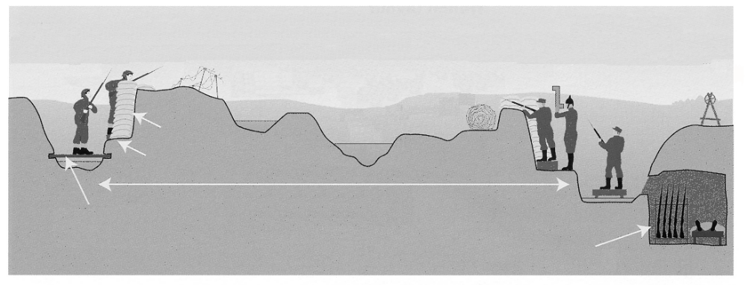

No Man’s Land
Artillery
3 kilometres
back
Parapet of
sand and earth
Barbed
wire
Shell holes often
filled with water
and mud
Barbed
wire
Periscope
Duckboards to
keep out of mud
Space between trenches could be anything
From 30 metres to 1 kilometre
Dugouts
(Sleeping Area)

These are the descriptions on the graphic, see the government website for where they are located on the diagram in the address below:
http://www.ed.gov.nl.ca/edu/k12/evaluation/worldhist3201/worldhist3201_jun07_gs.pdf

Use of Source:
The source shows the characteristics of the trenches and students could use the following to
support their answers:
• “No Man’s Land”: Troops faced each other across “stretches of land” that were
tremendously dangerous to cross, thus creating a stalemate.
• Advancement was difficult because of “shell holes”, no cover for troops
• “Barb wire” impeded or inhibited troop movement
• “No Man’s Land” characteristics
• “Shell holes often filled with water”, making it difficult to advance

Use of Knowledge
• Nature of trench warfare was defensive
• The trenches remained virtually stationary in spite of the massive battles fought
• There was little or no cover for troops in no mans land leading to massive casualties,
particularly as machine guns would focus their fire at gaps in the barbed wire where
troops would congregate.
• Snipers made exposure deadly
• Artillery shells filled with shrapnel proved deadly to exposed troops
• Because the trenches extended along the entire length of the western front, there was no
opportunity to outflank the enemy. As a result only frontal attacks were possible.
• Attempts were made to break the stalemate but technology was not up to the task, nor
was the strategy and tactics of the day.

Using the source provided and your knowledge of history, assess how British and
German attitudes contributed to the outbreak of World War I.

Source
“I had a peculiar passion for the navy. It sprang to no small extent from my English
blood. When I was a little boy... I admired the proud British ships. There awoke in me
the will to build ships of my own like these some day, and when I was grown up, to
possess a fine navy as the English.”
- My Early Life, German Kaiser Wilhelm II

Answer
Use of Source
• The document suggests that it was Kaiser Wilhelm II’s aspiration or attitude for a world
class navy that led to tensions between Germany and Britain. This led to a naval race
between Britain and Germany.
• Germany, historically, had no need for a navy, being largely a land based power. When
the Kaiser came to power in 1888, he changed Germany‘s foreign policy to acquire an
empire and a world class navy to do it.
• This led to increased tensions and an arms race (naval in nature) between the two
countries.
Use of Knowledge
• Britain also felt compelled to end its “Splendid Isolation” in favor of an alliance with its
traditional enemy France.
• Britain did not want to willingly go to war but were willing to do so if it was due to
threats to their empire, naval dominance or due to a shifting balance of power in Europe.
• Germany considered war to be a natural and desirable occurrence in order to air out
differences and to establish its dominance over others. This attitude provided no braking
mechanism to stop German involvement in a situation such as the one that developed
after the assassination of the Franz Ferdinand.
• Britain wish to maintain the “Status Quo”
• Germany wanted its “place in the sun”
• Germany believed that war was necessary to end European tensions.
• Both sides believed that WW I would be a short war.
Commentary on Response
Generally, students had an understanding of the attitudes held by Britain and Germany on
the eve of war.

